Project Design Phase-II

Data Flow Diagram & User Stories

|  |  |
| --- | --- |
| Date | 03 October 2022 |
| Team ID | PNT2022TMID22747 |
| Project Name | Visualizing and Predicting Heart Diseases with an Interactive Dash Board |
| Maximum Marks | 4 Marks |

# Data Flow Diagrams:

A Data Flow Diagram (DFD) is a traditional visual representation of the information flows within a system. A neat and clear DFD can depict the right amount of the system requirement graphically. It shows how data enters and leaves the system, what changes the information, and where data is stored.

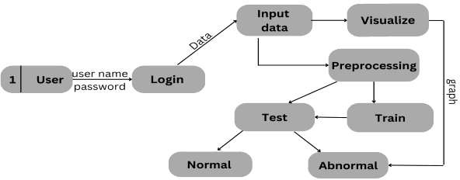

# FLOW:

In the application, the user creates an account.

1. The user enters the medical information in the dashboard.
2. The user can explore trend visualisations for his or her medical records using the learned dataset as graphs and charts.
3. In the dashboard, the user can see the accuracy of the probability of developing heart disease.

# User Stories

Use the below template to list all the user stories for the product.

|  |  |  |  |  |  |  |
| --- | --- | --- | --- | --- | --- | --- |
| **User Type** | **Functional Requirement (Epic)** | **User Story Number** | **User Story / Task** | **Acceptance criteria** | **Priority** | **Release** |
| Customer (Mobile user) | Registration | USN-1 | As a user, I can register for the application by entering my E mail password and confirming  my password. | I can access my account / dashboard | High | Sprint-1 |
|  |  | USN-2 | As a user, I will receive confirmation Email once I have registered for the application | I can receive confirmation email & click confirm | High | Sprint-1 |
|  | Login | USN-3 | As a user, I can register for the application through Facebook | I can register & access the dashboard with Facebook Login | Low | Sprint-1 |
| Customer (Web user) | Dashboard | USN-4 | As a user, I can register for the application through Gmail | I can register & access the  dashboard with Facebook Login | Medium | Sprint-2 |
|  |  | USN-5 | As a user, I can log into the application by entering email & password | I can register & access the dashboard with Facebook Login | High | Sprint-2 |
| Customer Care Executive | Helpdesk | USN-6 | As a user, I can log into the application by entering email & password | I can register & access the dashboard with Facebook Login | High | Sprint-3 |
|  |  | USN-7 | As a user, I can log into the application by entering email & password | I can register & access the dashboard with Facebook  Login | Medium | Sprint-3 |
| Administrator | User Profile | USN-8 | As a user, I can log into the application by entering email & password | I can register & access the dashboard with Facebook Login | High | Sprint-4 |

|  |  |  |  |  |  |  |
| --- | --- | --- | --- | --- | --- | --- |
| **User Type** | **Functional Requirement (Epic)** | **User Story Number** | **User Story / Task** | **Acceptance criteria** | **Priority** | **Release** |
|  |  | USN-9 | As an admin, he/she can add or delete | I can register & access the dashboard with Facebook  Login | High | Sprint-4 |
|  |  | USN-10 | As an admin, he/she can manage the user details | I can register & access the  dashboard with Facebook Login | High | Sprint- 4 |